

**Mid-Term Project Report**

**On**

**Electric Charging Station Recommendation System**

**Submitted By:**

Rajat Budhathoki (20820/075)

Bipin Chaudhary (20800/075)

Abhinna Ojha (20788/075)

**Submitted To:**

Utsab Koirala

Lecturer

Orchid International College

DEPARTMENT OF COMPUTER SCIENCE AND INFORMATION TECHNOLOGY

ORCHID INTERNATIONAL COLLEGE

Acknowledgement

We would also like to convey special gratitude towards our supervisors and mentors, Mr. Utsab Koirala, Mr. Dhiraj Kumar Jha, Ms. Shikha Sharma, and Mr. Diwakar Upadhyaya, who provided us with immense guidance and support that not only helped us to complete the project but also learn valuable lessons and guidelines in the process. In spite of their busy schedule, they made sure that our concerns and queries were addressed and were present even on the oddest time of the day.

Furthermore, we would also like to extend my gratitude to the staff and faculty of Orchid International College for their constant support and co-operation throughout the timeframe. Sincere appreciation to all my friends and colleagues who were directly or indirectly helpful for the completion of this project.

Abstract

Electric vehicles, EVs, are gaining popularity in recent years. Similarly, recommendation systems are also nowadays used on almost every walk of digital life. The increasing adoption of EVs has led to a growing demand for charging infrastructure. However, finding a charging station that is both conveniently located and available can be a challenge for EV drivers. The problem of finding suitable charging station is further complicated by the type of charging port of the EV. And as charging an EV is not as fast and only some charging stations are equipped with fast charging port, EV drivers and owners face a dilemma on whether a certain location even has a charging station or not, and is the charging station is suitable for them or not. Our system aims to provide users a web-based platform that can recommend the potentially suitable charging station to them.

**Keywords:** Electric Vehicle (EV), Charging Station, Recommendation System, Cosine Similarity, Laravel

Table of Contents

Acknowledgement i

Abstract ii

Table of Contents iii

List of Abbreviations v

List of Figures vi

1. Chapter 1: Introduction 1

1.1. Introduction 1

1.2. Problem Statement 1

1.3. Objectives 1

1.4. Scope and limitation 2

1.5. Development Methodology 2

1.6. Report Organization 3

2. Chapter 2: Background Study and Literature Review 4

2.1. Background Study 4

2.2. Literature Review 5

3. Chapter 3: System Analysis 6

3.1. Requirement Analysis 6

3.1.1. Functional Requirements 6

3.1.2. Non-Functional Requirements 8

3.2. Feasibility Study 9

3.2.1. Technical Feasibility 9

3.2.2. Operational Feasibility 9

3.2.3. Schedule Feasibility 10

3.3. Analysis 11

3.3.1. Class diagram 11

3.3.2. Activity Diagram 12

4. Chapter 4: System Design 13

4.1. Design 13

4.1.1. Model View Controller architecture 13

4.2. Algorithm Details 13

4.2.1. Collaborative Filtering 13

4.2.2. Cosine Similarity 14

5. Implementation 15

5.1. Tools used 15

5.2. Database implementation 15

References and Bibliography 16

List of Abbreviations

EV Electric Vehicle

EVCS Electric Vehicle Charging Station

L-ION Lithium Ion

ICE Internal Combustion Engine

MVC Model View Controller

HTML Hyper Text Markup Language

CSS Cascading Style Sheets

JS JavaScript

PHP Hyper Text Pre-processor

List of Figures

Figure 1: Agile methodology 2

Figure 2: Use case of the System 6

Figure 3: Gantt chart 10

Figure 4: Class diagram 11

Figure 5: Activity diagram to provide rating or receive recommendation 12

Figure 6: Model View Controller architecture 13

Figure 7: Database implementation 15

# Chapter 1: Introduction

## Introduction

Electric vehicles, EVs, are gaining popularity in recent years. The reduction of taxes by various nations on EVs, the consideration of environment, and the ever-depleting petroleum resources has made EVs a possible vehicle in consideration for many drivers and the easier and cheaper availability of electricity further solidifies the case for the choice of EVs. Similarly, recommendation systems are also nowadays used on almost every walk of digital life. The increasing adoption of electric vehicles (EVs) has led to a growing demand for charging infrastructure. However, finding a charging station that is both conveniently located and available can be a challenge for EV drivers. The aim of this project is to address this challenge by providing a user-friendly and efficient solution for recommending charging stations. The system utilizes the technique of cosine similarity to recommend the most suitable electric vehicle charging stations in a specified location. The report will detail the design, implementation and evaluation of the system, as well as its overall performance and potential future improvements.

## Problem Statement

The big problem of Electric Vehicles (EV), is charging. EV charging is not as easy as filling up fuel as in an internal combustion engine-based vehicle as it takes quite a significant time for the EV to be fully charged. So, picking an EV charging station can be a big personal preference-based choice and finding a right one can be a topic of choice. With the scarce availability of the EV charging stations, it can be very difficult to even look for an EV charging station let alone being recommended one that a person may like, trust, and ultimately prefer.

## Objectives

1. To implement user-user-based collaborative filtering using cosine similarity
2. To create a web-based recommendation system that recommends EV charging stations in an area

## Scope and limitation

The project aims to build a system that can be used to provide ratings to various charging stations and receive recommendation of charging station in a user specified location.

The system will not detect the user location of provide routes to the said charging stations.

## Development Methodology

The project is developed using agile methodology. Agile methodology is a way to manage a project by breaking it up into several phases. It involves constant collaboration with stakeholders and continuous improvement at every stage. Once the work begun, we cycled through a process of planning, executing, and evaluating. Continuous collaboration is vital, both with team members and project stakeholders. Following the Agile methodology, we focused on working software over comprehensive documentation and we responded to changes and feedbacks over following a hard-and-fast plan.

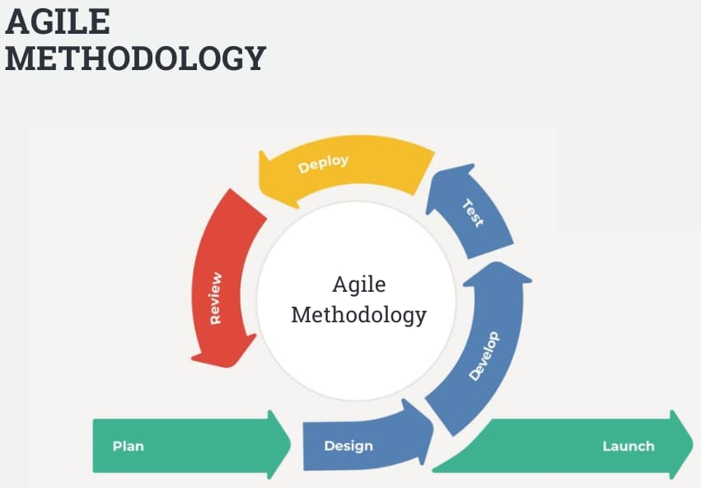

Figure 1: Agile methodology

## Report Organization

The project follows the SDLC process which consists of:

1. Requirement Analysis
2. Planning
3. Analysis
4. Design
5. Implementation
6. Testing
7. Deployment and Maintenance

# Chapter 2: Background Study and Literature Review

## Background Study

Electric Vehicle is not a new concept. It has been a topic of discussion and research as an alternative fuel vehicle since the beginning of 21st century. With the breakthrough in research in recent years, and a global awareness of the adverse climatic effects due to fossil fuels, electric vehicles has been a prominent and upcoming field of research.

The biggest problem of the EV is the travel distance as the per charge range is significantly lower than the per tank range of ICE based vehicles. The other fuel system is the use of Hydrogen fuel, but the problematic storage of Hydrogen and Oxygen required for the fuel cell makes the process of fuel cell-based vehicles a challenging concept. Solar power can be used, but solar power produces inconsistent power and may be subject to higher cost due to the innate costs of the panels, maintenance, and repair. So, with careful consideration to all the possibilities, EVs with L-ION batteries and accessible charging stations seems to be the most likely future for the next few decades. Research in EVs have been prominent and research into ways to increase the range of EVs have been a topic of heavy interest. But, for now, it seems though that the availability of suitable EVCS is the better approach towards EV charging.

Furthermore, most of the EVCS recommendation system is based on technicalities. EV charging is treated as ICE vehicle fuelling and recommendations are based on technical parameters only. While technical parameters are important and effective, EV charging is more than just the technicalities. EV charging is not as quick and robust as ICE fuelling and the human aspect is mostly neglected by most researches and systems. While recommendation systems like that of movies is based on human preferences, the recommendation system of EVCS mostly does not consider potential human factors like what will they do during the downtime when their vehicle is charging and how can recommendation be made more human-centric.

## Literature Review

Many prominent researches have been done on the recommendation systems and few of them are based on the electric vehicle charging station.

In a study on Electric Vehicles in Hyderabad [1], the authors conducted research on the EV taxies in Hyderabad, and how can the EVCS recommendation be beneficial to the EV taxies. The EV taxies were compared based on real and simulated recommendations with an accuracy of 94.7%, among which the accuracy of to-station state prediction is 92.2%, 96.8% for recharging, and 95.3% for operating. The comparison of real selections with predicted selections was obtained as 84.7% on integral recharge intention identification,

including to-station state, and charging station selection.

Research in a similar system [2] was conducted in 2021 which discusses recommendation system of EVCS. The research focused on various parameters like charging request, charging wait time, charging price, and charging failure rate to recommend the most proper charging station with long term goals of minimising the charging wait time, charging price, and charging failure rate.

A similar study in Tamil Nadu [3] proposes a system for the EV charging station recommendation system for load based taxis. The study suggested that EV taxis’ long time cost at charging stations results from the EV taxi drivers always rushing to the same charging stations during the same period. Furthermore, the preliminary observations and analysis of recharging behaviour patterns suggest the necessity of the charging station recommendation system. The system also suggested the use of real-time recommendation system so that the taxi drivers can get real time suggestions so that they do not rush only to the charging stations they frequently use.

The study [4] in Beijing in 2021 also proposed a similar recommendation system, albeit using federated learning. The research compared the model based on real data and that based on their model and concluded that the model was accurate by a factor of 0.92, 92%.

# Chapter 3: System Analysis

## Requirement Analysis

### Functional Requirements

#### Use-case diagram

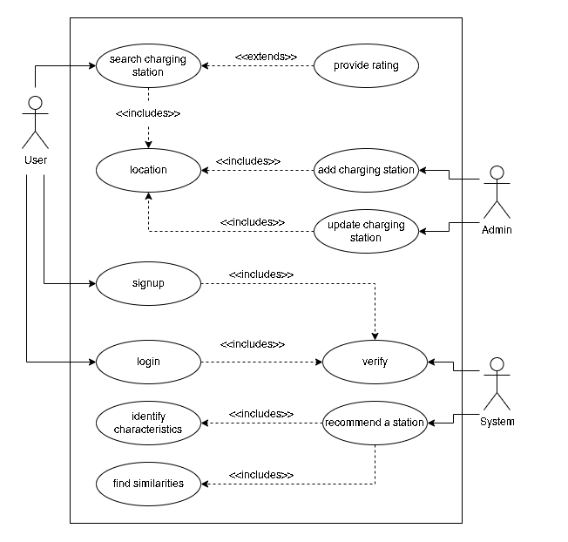

Figure 2: Use case of the System

#### Use-case descriptions

|  |  |
| --- | --- |
| **Identifier** | UCD1 |
| **Name, Description** | Providing the rating to a charging station |
| **Actors** | User |
| **Pre-condition** | The location must be specified and charging station must be selected |
| **Post-condition** | Message is displayed to user, rating is inserted |

|  |  |
| --- | --- |
| **Identifier** | UCD2 |
| **Name, Description** | Adding a charging station |
| **Actors** | Admin |
| **Pre-condition** | The location must be specified |
| **Post-condition** | Success message is displayed to admin after insertion, charging station is inserted |

|  |  |
| --- | --- |
| **Identifier** | UCD3 |
| **Name, Description** | Updating a charging station |
| **Actors** | Admin |
| **Pre-condition** | The location must be specified and the charging station to update must be selected |
| **Post-condition** | Success message is displayed to admin after update, charging station is updated |

|  |  |
| --- | --- |
| **Identifier** | UCD4 |
| **Name, Description** | User signup |
| **Actors** | User, System |
| **Pre-condition** | - |
| **Post-condition** | The user is logged in, user data is inserted and registered |

|  |  |
| --- | --- |
| **Identifier** | UCD5 |
| **Name, Description** | User login |
| **Actors** | User, System |
| **Pre-condition** | The user must be registered |
| **Post-condition** | The user is logged in |

|  |  |
| --- | --- |
| **Identifier** | UCD6 |
| **Name, Description** | Recommending a charging station |
| **Actors** | System, User (secondary) |
| **Pre-condition** | The similarity scores must be up to date |
| **Post-condition** | The charging stations are recommended after analysis of parameters |

### Non-Functional Requirements

1. Speed: It is used to determine how fast the system performs certain activities.
2. Security: Only registered users can login to the system and provide ratings or get recommendations.
3. Availability: The system will be available at all hours, everyday of the year once deployed.
4. Usability: The system should be easy to access, use, and understand by the users

## Feasibility Study

### Technical Feasibility

The dataset to train and test the recommendation system can be available from sources like NEA and Kaggle. Laravel framework would be used to build the recommendation system and the collaborative filtering technique with cosine similarity would be used for the recommendation algorithm. The next step would be to develop the recommendation system using the Laravel framework and the chosen algorithm. This would involve the implementation of various features such as user authentication, data management, and recommendation generation. The developed system would then be tested to ensure its functionality and performance. This would involve evaluating the system's accuracy and efficiency in generating recommendations, as well as user satisfaction with the system. Once the system has been tested and evaluated, it would be deployed for use by EV owners. This would involve the integration of the system with existing EV charging stations and the implementation of any necessary security measures.

All in all, the technical feasibility of this project is high as the Laravel framework is a robust and widely used platform for web development, and collaborative filtering with cosine similarity is a well-established recommendation algorithm. With the appropriate data and resources, the development, testing, and deployment of this system is achievable.

### Operational Feasibility

The system will be able to recommend the EV charging station to the user in the specified location. This recommendation will be based on the ratings the user has provided to the EV charging stations that the user has already been to and rated. This solves the problem for the user to manually search the EV charging station and make a guess of whether the one they found may be one of their liking or not and whether they will be able to trust their expensive vehicles on the said charging station or not. Furthermore, having a system of authentication and authorisation will also help prevent fake ratings and make the system more reliable and robust.

### Schedule Feasibility

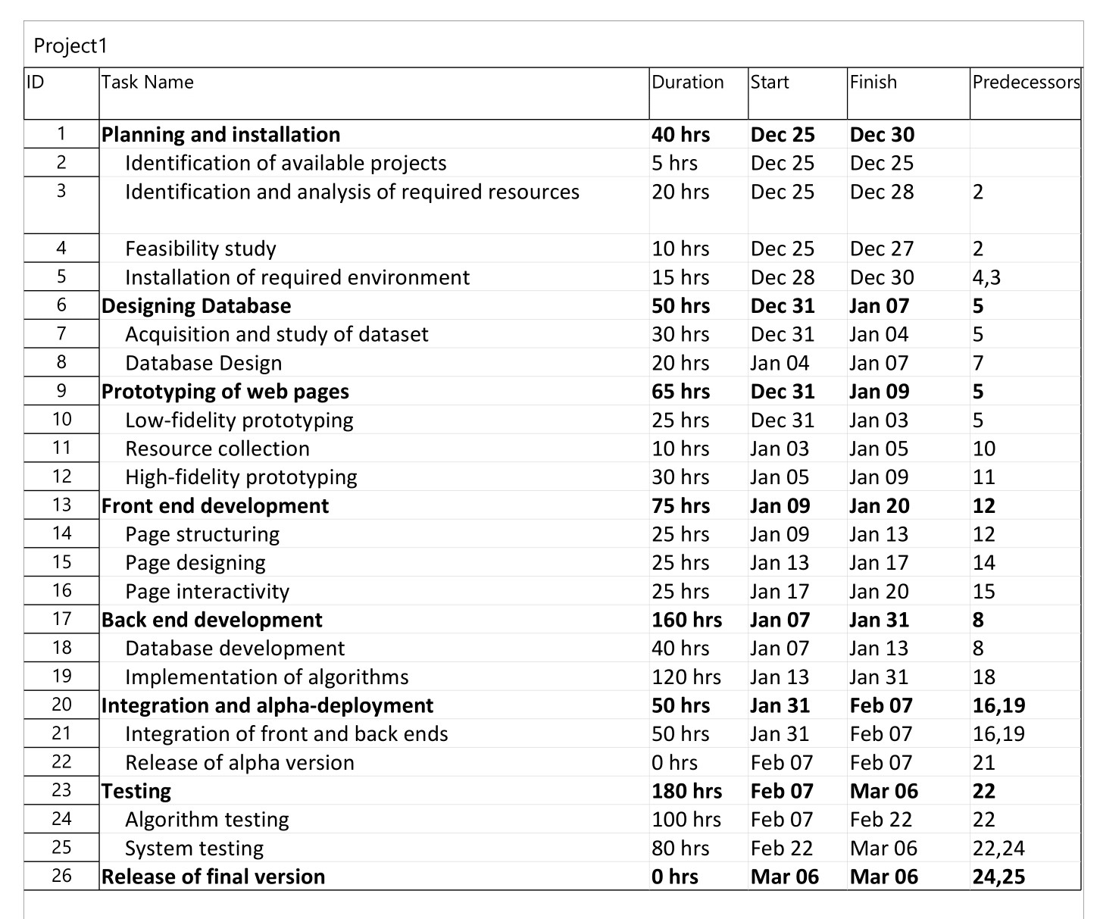

Figure 3: Gantt chart

## Analysis

### Class diagram

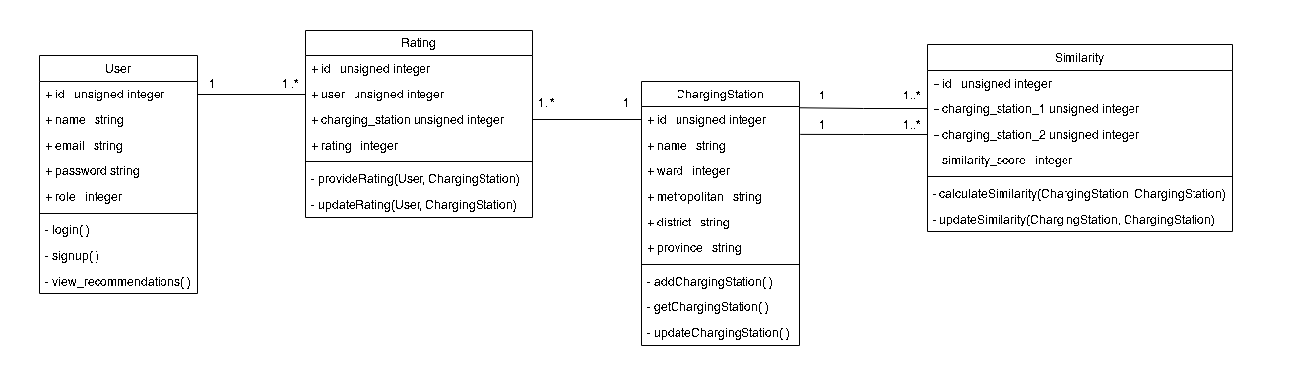

Figure 4: Class diagram

### Activity Diagram

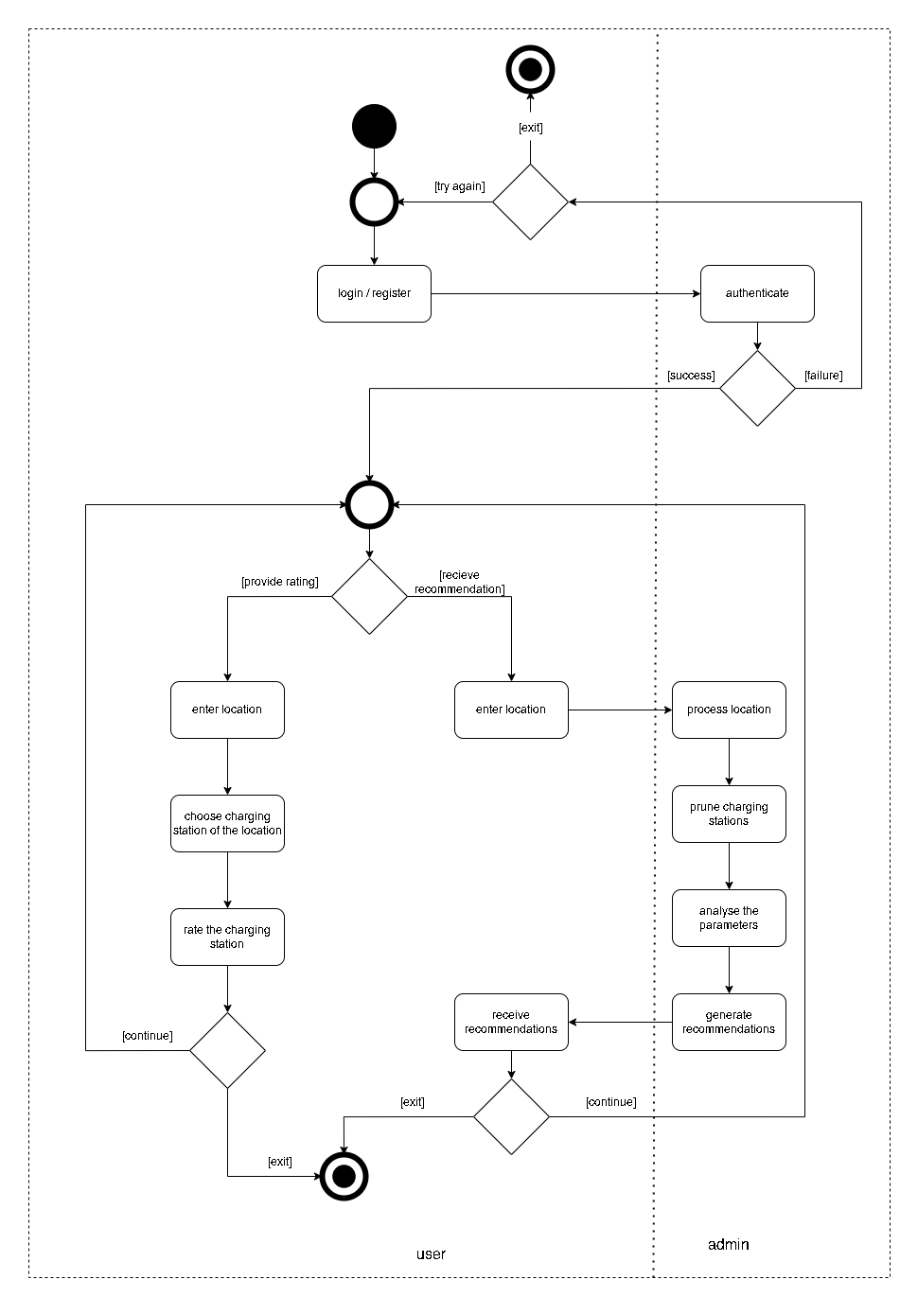

Figure 5: Activity diagram to provide rating or receive recommendation

# Chapter 4: System Design

## Design

### Model View Controller architecture

The system is built following the Model View Controller, MVC, architecture. The model handles the data logic, database communication, and data on database. The controller contains the core business and implementation logic. It also acts as the intermediary between our model and view and helps render views via routes. The view renders the pages and acts as the presentation part of our system. As MVC is one of the most popular and efficient design architectures for web-based systems, we chose to se MVC architecture for our system.

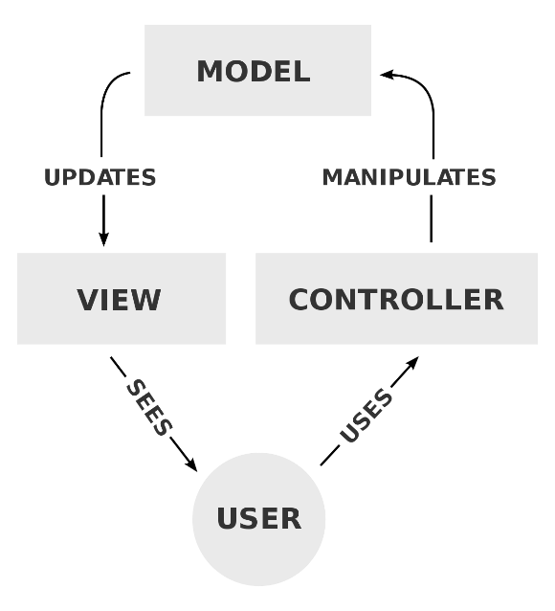

Figure 6: Model View Controller architecture

## Algorithm Details

### Collaborative Filtering

Collaborative filtering uses algorithms to filter data from user reviews to make personalized recommendations for users with similar preferences. Collaborative filtering is a method of making automatic predictions (filtering) about the interests of a user by collecting preferences or taste information from many users. The cosine-based approach defines the cosine-similarity between two users x and y as:

$$similarity\left(x, y\right)=\cos\left(\vec{x}, \vec{y}\right)= \frac{\vec{x}.\vec{y}}{\left|\left|\vec{x}\right|\right|.\left|\left|\vec{y}\right|\right|}= \frac{\sum_{i∈I_{xy}}{r_{x,i}r_{y,i}}}{\sqrt{\sum_{i∈I_{x}}{r_{x,i}^{2}}}.\sqrt{\sum_{i∈I_{y}}{r_{y,i}^{2}}}}$$

### Cosine Similarity

Cosine similarity is a measure of similarity between two sequences of numbers. The cosine similarity always belongs to the interval [-1, 1]. The cosine of two non-zero vectors can be derived by using the Euclidean dot product formula:

$$A.B= \left|\left|A\right|\right|.\left|\left|B\right|\right|.\cos{θ}$$

Given two n-dimensional vectors of attributes, A and B, the cosine similarity, cos(θ), is represented using a dot product and magnitude as:

$$S_{c}\left(A, B\right)=\cos{(θ)}= \frac{A. B}{\left|\left|A\right|\right| . \left|\left|B\right|\right|}= \frac{\sum_{i=1}^{n}{A_{i}.B_{i}}}{\sqrt{\sum_{i=1}^{n}{A_{i}^{2}}}. \sqrt{\sum_{i=1}^{n}{B_{i}^{2}}}}$$

where Ai and Bi are components of vector A and B respectively.

# Implementation

The implementation details as of date of mid-term defence.

## Tools used

1. diagrams.net
2. Microsoft Project
3. PHP Storm IDE
4. GitHub with Git
5. HTML and CSS
6. JS along with jQuery
7. PHP with Laravel
8. MySQL

## Database implementation

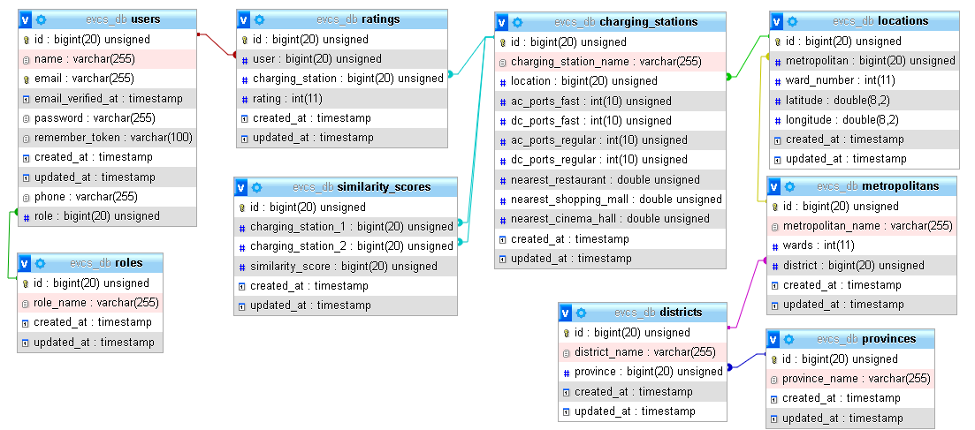

Figure 7: Database implementation

References and Bibliography

|  |  |
| --- | --- |
| [1] | A. K. Rakshan Urooj, “Persistent Charging Station Recommendation System for Electric-Vehicle Taxis,” International Journal of Scientific Engineering and Technology Research, Hyderabad, India, 2017. |
| [2] | H. L. F. W. T. X. H. X. D. D. H. X. Weijia Zhang, “Intelligent Electric Vehicle Charging Recommendation Based on Multi-Agent Reinforcement Learning,” International World Wide Web Conference Committee, Ljubljana, Slovenia, 2021. |
| [3] | P. P. R.Aarthi, “Enhanced Real-Time Charging Station Recommendation System For Load Base Electric-Vehicle Taxis,” South Asian Journal of Engineering and Technology, 2017. |
| [4] | X. Z. X. L. Xiaohui Wang, “Charging Station Recommendation for Electric Vehicle Based on Federated Learning,” Artificial Intelligence on Electric Power System State Grid Corporation Joint Laboratory, Beijing, China, 2021. |
| [5] | T. M. K. Xiaoyuan Su, “A Survey of Collaborative Filtering Techniques,” 2009. |
| [6] | A. Singhal, “Modern Information Retrieval: A Brief Overview,” Google, Inc.. |
| [7] | L. R. a. B. S. Francesco Ricci, Introduction to Recommender Systems Handbook, 2011. |